**INTRODUCTION**

Coral reef habitats are among the most biologically diverse ecosystems on the planet. They provide essential services such as protecting the shoreline, serving as vital habitat for fish and other organisms and functioning as a tourist destination with economic value (Barbier 2011). The unique growth forms that provide the structural framework and rugosity of coral reefs are primarily due to the calcification of hermatypic stony corals in the order Scleractinia. Such calcification is made possible by the formation of a mutualistic endosymbiosis with photosynthetic dinoflagellates in the order Symbiodinium through which the coral host gains the majority of its required nutrients as photosynthate from the symbiont (Baker 2003; Berkelmans et al. 2006).

Scleractinian corals are known to associate with a diverse array of *Symbiodinium*.Nine divergent clades (A-I) exist among *Symbiodinium* spp. based on the internal transcribed spacer (ITS) region on nuclear ribosomal DNA (Pochon et al. 2010). This diversity in symbiosis potentially arises from factors such as host species, depth, spatial distribution and irradiance, though few studies have investigated this (Abrego 2009; Iglesias-Prieto et al. 2004; LaJeunesse 2001). Though *Symbiodinium* can occupy nine clades, four clades (A-D) comprise the vast majority. Clades A and B tend to exist in Atlantic corals, while corals in the Pacific predominantly harbor clades C and D, with C being the most common (LaJeunesse et al. 2004; Jones et al. 2008).

Each symbiont clade has characteristic levels of stress-tolerance and physiological optima (Boulotte et al. 2016). Clade D has shown higher levels of thermal tolerance and photoprotection, yet growth rates and photosynthetic efficiency of clade D-dominated corals are often depressed, posing tradeoffs in harboring this strain (Little et al. 2004; Rowan 2004). Conversely, clade C *Symbiodinium* tend to be less tolerant of thermal stress, yet more idealistic because of their capacity to incorporate a larger proportion of photosynthate into the coral host’s tissues (Cantin et al. 2009). Because of this, clade D potentially functions as an opportunistic symbiont that dominates as a response to recent stress anomalies (Baker 2003; Cantin et al. 2009; Stat et al. 2013).

Little is known about the environmental factors contributing to the spatial distribution of symbiont variability however. Evidence of biogeographic patterns on inshore versus offshore reefs, across latitudinal gradients and even within the same reef environment exists. The factors driving these patterns are important for understanding coral response to climate change’s effect on the local environment (Garren et al. 2006; Stat et al. 2011).

*Montipora capitata*, one of the dominant reef-building species in Kāne’ohe Bay,is atypical in its ability to harbor multiple symbiont clades. The majority of coral species tend to be quite specific, relying on a single symbiont clade (Goulet 2006). *Symbiodinium* clades C and D are the dominant clades observed in Kāne’ohe Bay and are both found in the tissues of *M. capitata* (Rowan et al. 1991; Stat et al. 2013). While colonies are typically dominated by one clade over the other, the presence of heterogeneous mixtures of multiple symbionts, like that observed in *M. capitata*, suggests a potential for symbiont shuffling or switching in response to climate change (Jones et al. 2008). Few studies have investigated the patterns of association between the two symbionts, particularly when considering differences in habitat. *M. capitata* is an essential study species in Hawai’i because it is a dominant reef-builder with the capacity to host multiple symbionts, possibly demonstrating increased survivorship potential.

Kāne’ohe Bay is a unique environment with a strong history of disturbance. Both from environmental and anthropogenic influences, these anomalies are potential drivers of symbiont distribution (Cooper 2011; Stat et al. 2011). The patch and fringing reef systems of Kāne’ohe Bay are quite shallow; some sections of the reef tops can be exposed during low tides (Bahr et al. 2015). Shallow depths, along with restricted circulation throughout the bay, pose negative implications for thermal stress, which has been observed in successive bleaching events in 2014 and 2015. Despite its seemingly intolerable physiognomies, there exists high coral coverage and rapid recovery rates from stress events in Kāne’ohe Bay. In light of these recent bleaching anomalies, this study aimed to characterize the spatial patterns of *Symbiodinium* clades C and D to investigate the potential stress-response of the Kāne’ohe Bay population of *M. capitata*.

**METHODS**

*Study Design and Location*

Individual colonies of *M. capitata* were tagged and sampled to explore the spatial variability of *Symbiodinium* clades C and D found in colonies from different habitats. All corals were sampled from Kāne’ohe Bay, located on the east side of O’ahu, Hawai’i, USA. Corals were tagged with medium-sized yellow cattle tags throughout the bay. Colonies at five patch reefs and three fringing reefs were tagged in each of the northern, central and southern regions of the bay with an additional submerged patch reef south of the Hawai’i Institute of Marine Biology. At each patch reef, 30 colonies were tagged; 10 colonies each from windward slope, top and leeward slope with depth recorded using a depth gauge. Given the lack of leeward slope on fringing reefs, 20 colonies were tagged at each site; 10 colonies each from the top and slope. At the tops of the patch reefs and the fringe sites most colonies were between 0 and 1 meter depth. Along the windward and leeward slopes, colonies were tagged randomly at a depth from 1 meter to 13 meters. Reefs lacking sufficient colonies from depths greater than 5 meters were re-visited and five additional colonies were sampled. Depth was later adjusted according to differences in mean sea level using NOAA’s daily tide tables for Moku o Lo’e, Kāne’ohe Bay at 6-minute intervals. In total, 16 patch reefs and 9 fringing reefs were sampled across Kāne’ohe Bay resulting in a sample size of 707 colonies. Tagging, photographing and sampling of colonies took place between 7 June 2016 and 12 August 2016.

*Sample Collection and Processing*

Ten weights with attached floats were randomly cast from the surface across a distance of approximately 20 meters on each reef area (top and both slopes). The closest colony of *M. capitata* in proximityto each float was tagged and sampled. Each sample consisted of a small branch fragment (~4-5cm) taken from the tip of a branch located at the top of the colony. *In situ* photographs with an included scale bar and color standard were taken of each colony to later be used for color assignment of each colony (Fig. 1). The coral fragment was subsampled for a tissue biopsy shortly after collection (never greater than 1.5 hours), which was placed in 500μL DNA buffer (5M NaCl, 0.5M EDTA) with 1% sodium dodecyl sulfate (SDS). The remaining fragment was immediately frozen in liquid nitrogen and archived at -80°C in the laboratory. DNA was extracted from each sample biopsy following a modified CTAB-chloroform protocol (dx.doi.org/10.17504/protocols.io.dyq7vv).

*Symbiont Community Analysis*

Quantitative PCR (qPCR) was used to analyze the symbiont community of each collected sample. Based on amplification of the internal transcribed spacer (ITS2) region, sequences of *Symbiodinium* clades C and D resulted from clade-level primers and probes (Cunning et al. 2013). All samples were assayed with primers of both clades C and D in duplicate 10μL reactions on a StepOnePlus platform (Applied Biosystems) for 40 cycles. Parameters were set at a fluorescence threshold of 0.01 and a baseline interval of cycles 15-22. The StepOnePlus software produced the target symbiont ratio of clade C to D in each sample, normalized for fluorescence intensity and locus gene copy number. Symbiont clades detected in only one qPCR reaction were not considered. The proportion of clade C dominance was calculated from the clade C to D ratio by the formula [(C:D)/(C:D+1)]. The resulting proportion of clade D dominance was then calculated by the formula 1-[(C:D)/(C:D+1)]. Based on the proportion values of clades C and D, the dominant symbiont type was determined. If a colony harbored both symbiont clades, designated as a heterogeneous mixture, the clade present in higher proportion was noted as CD or DC accordingly.

*Data Analysis*

Chi-Squared tests were used to assess differences in dominant symbiont clade, colony color morph and heterogeneous mixtures between reef areas (top vs. slope), bay areas (northern, central and southern) and reef types (patch vs. fringe). To estimate the probability of occurrence of dominant symbiont, color morph and heterogeneous mixture as a function of increasing depth, logistic regressions of generalized linear models were used. Depth was standardized according by adjusting for differences in mean sea level using daily tide tables for Moku o Lo’e, Kāne’ohe Bay at 6-minute intervals.

**FIGURES**

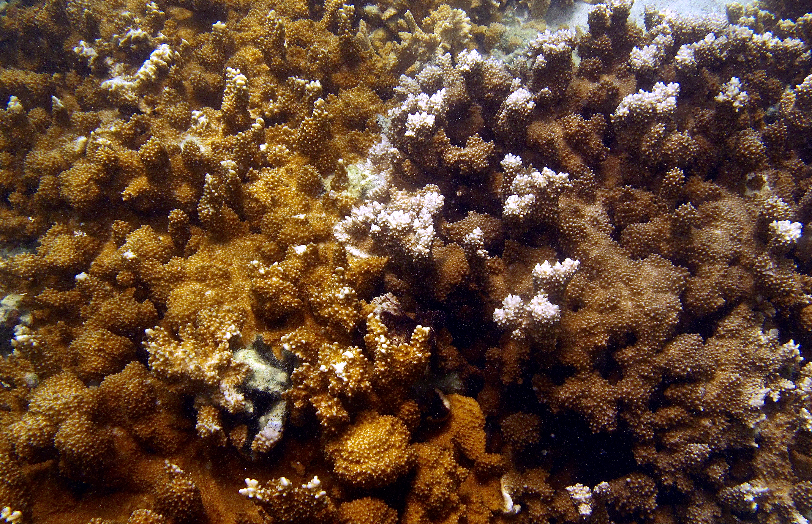

Fig. 1